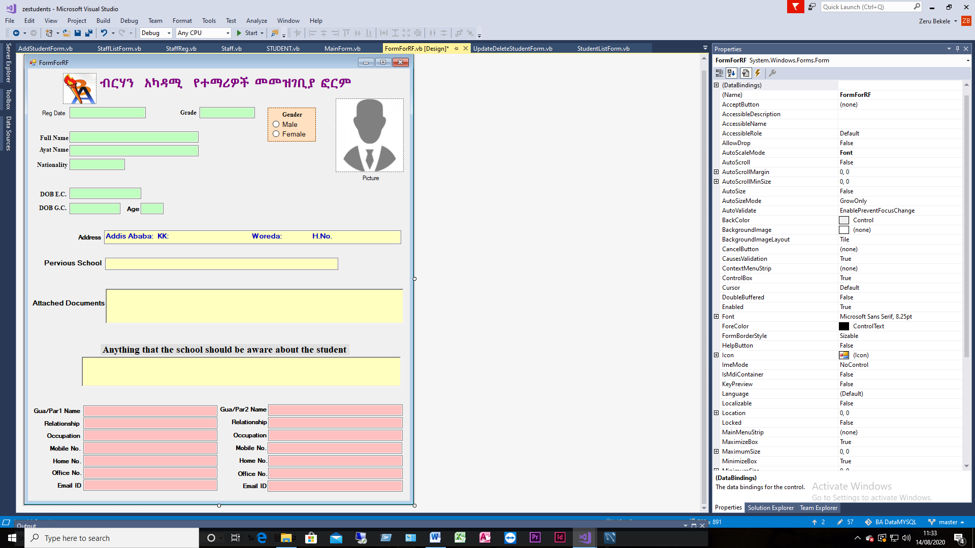

**Visit us on** [**www.birhan2020.com**](http://www.birhan2020.com) **Email** [**admin@birhan2020.com**](mailto:admin@birhan2020.com) **Call us on +251114668880**